

**UNIVERSITY OF PETROLEUM AND ENERGY STUDIES**

**School of Computer** **Science**

**2020-21**

**GRAPHICS AND ANIMATION TOOLS LAB**

**Faculty: Dr. DURGANSH SHARMA**

**Assistant Professor**

**Department of Cybernetics.**

**School of Computer Science, UPES**

**Submitted By:**

**Name- Garima Dhall**

**Roll no-R100217025**

**Batch-B1**

**Semester- 7**

**Course-B.tech. CSE-OSOS**

**Sap Id- 500062498**

**EXPERIMENT NO 3**

**Aim** :- Design of Google Logo using GIMP.

**Objective** :- To Design a Google logo using features of GIMP.

**STEPS TO MAKE LOGO :-**

1. Open GIMP workspace on your device and create a new template with demensions of your choice

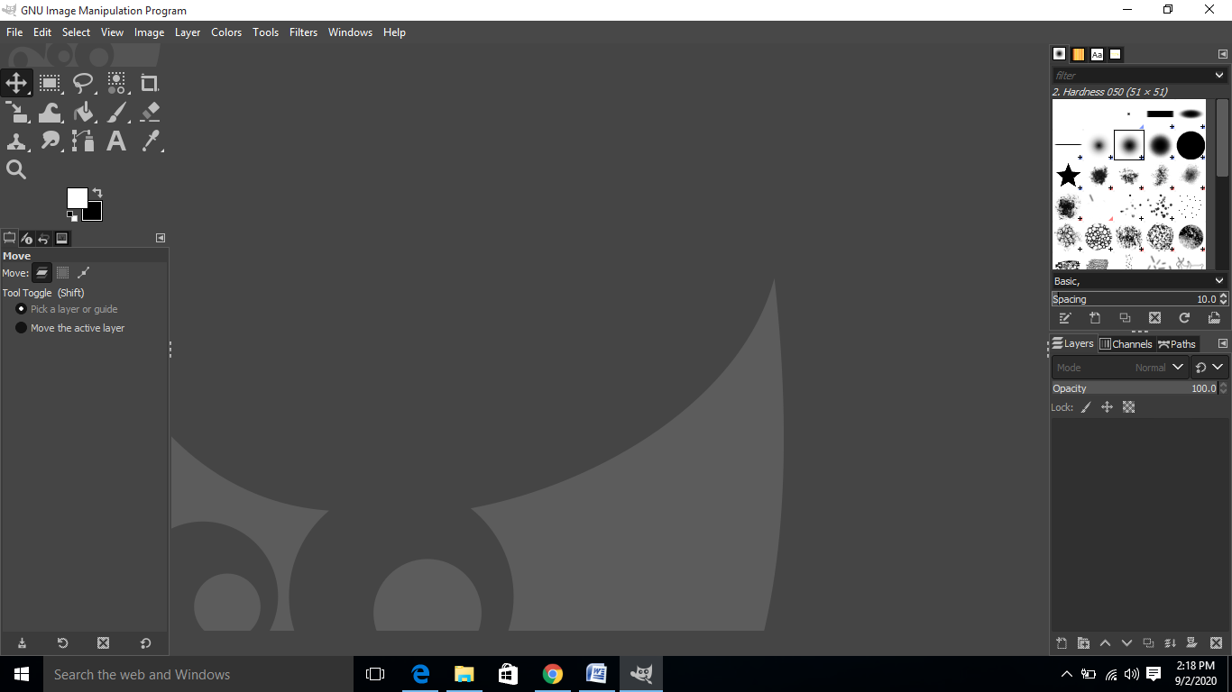

1. Then click on option image and select guide and then click on new guide by percent add both horizontal as well as vertical guide

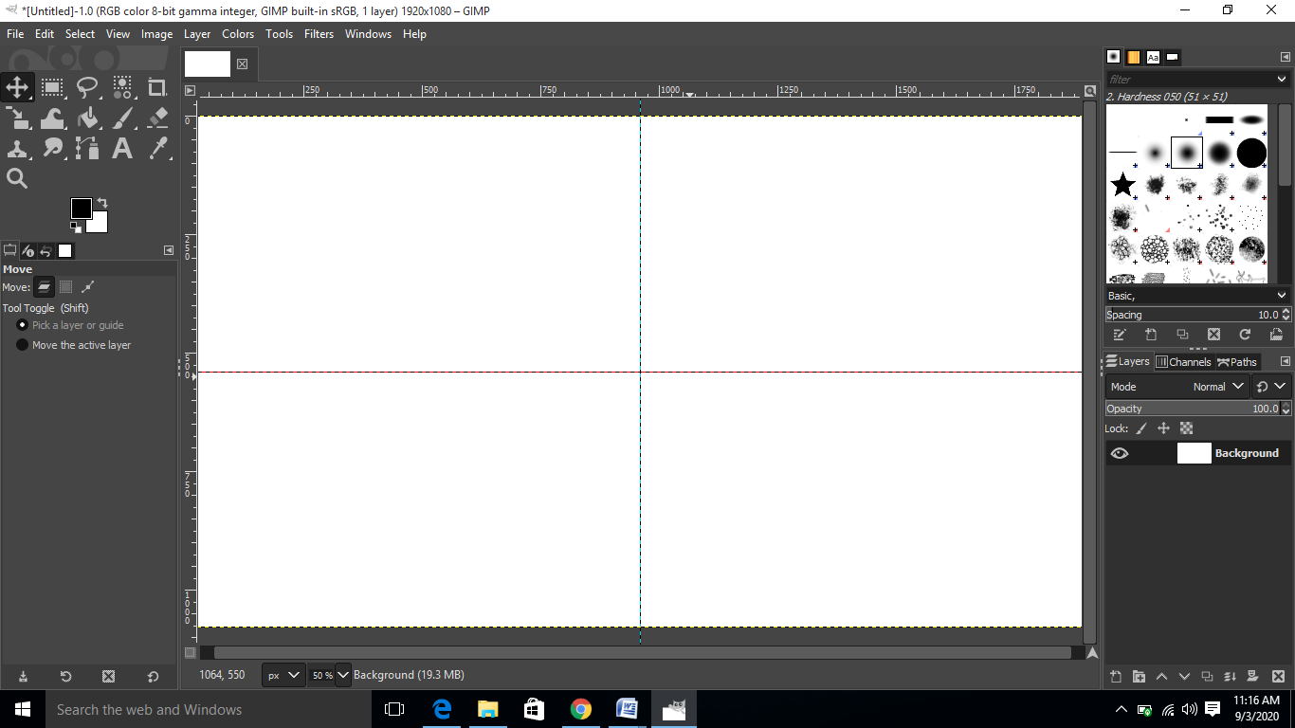

1. After the guides are construct go on the tools and select eclipse select tool and draw the eclipse in the centre

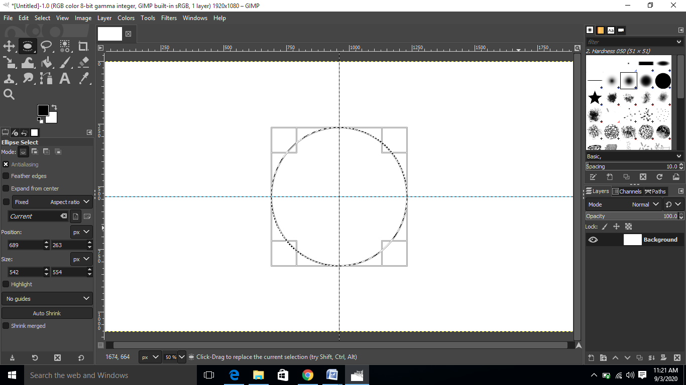

1. After drawing the eclipse then we click on select then click on To path and then select to none and after that click on path and select the eye button your eclipse will appear on the screen

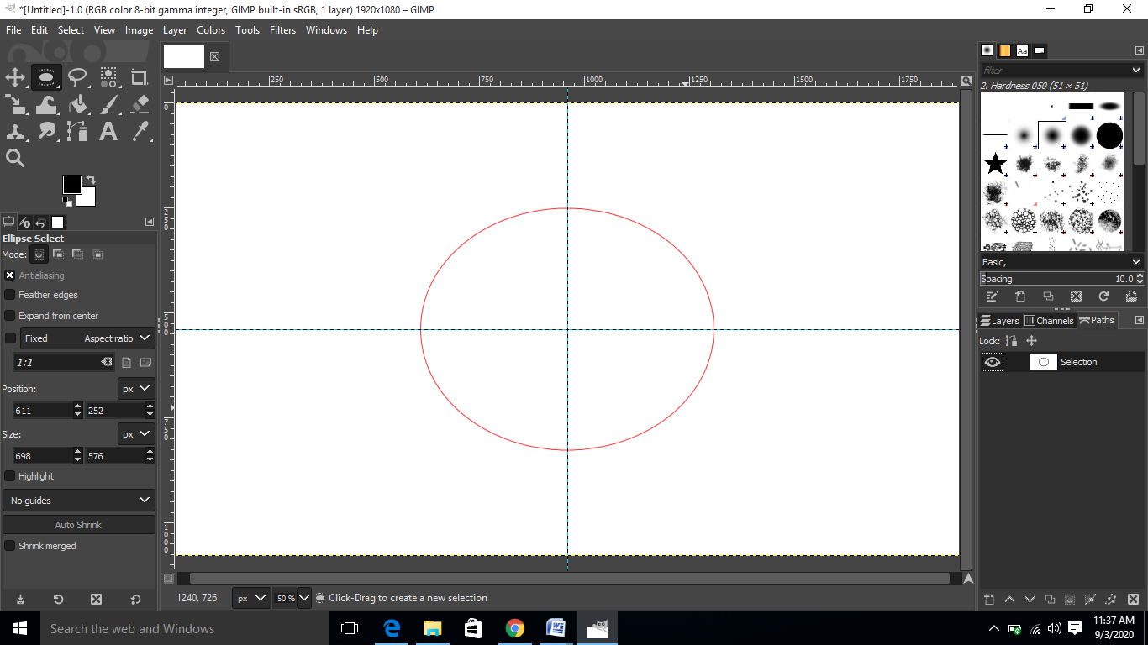

1. Then after that we will write the text which we want to wrap around it

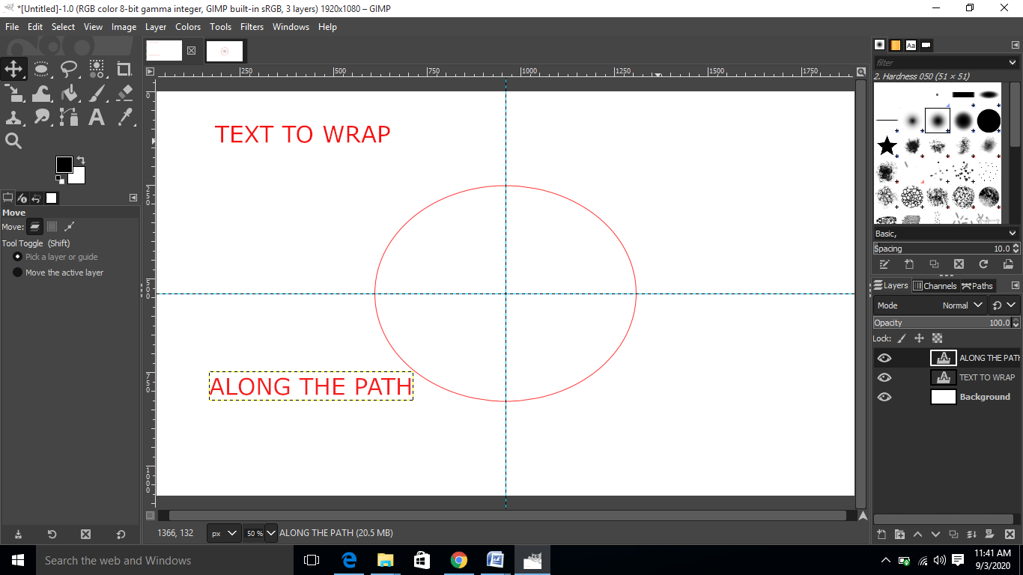

1. After that we will wrap the text along the eclipse by right on the layer of the text and click on option along the path and then we will hide the visibility of the text layer

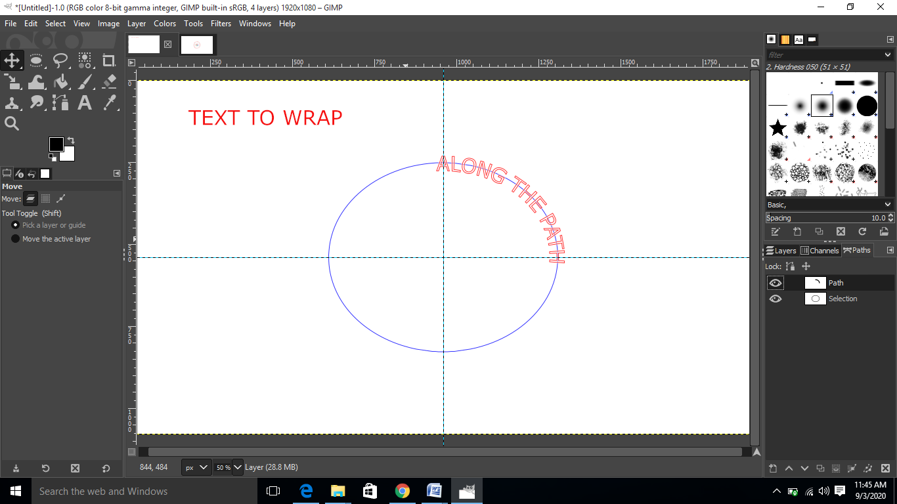

1. After doing this we will make a new layer and then we will go to paths and select path to selection option and then we will fill the text with foreground color and then we will click on option select none and then we will delete the path

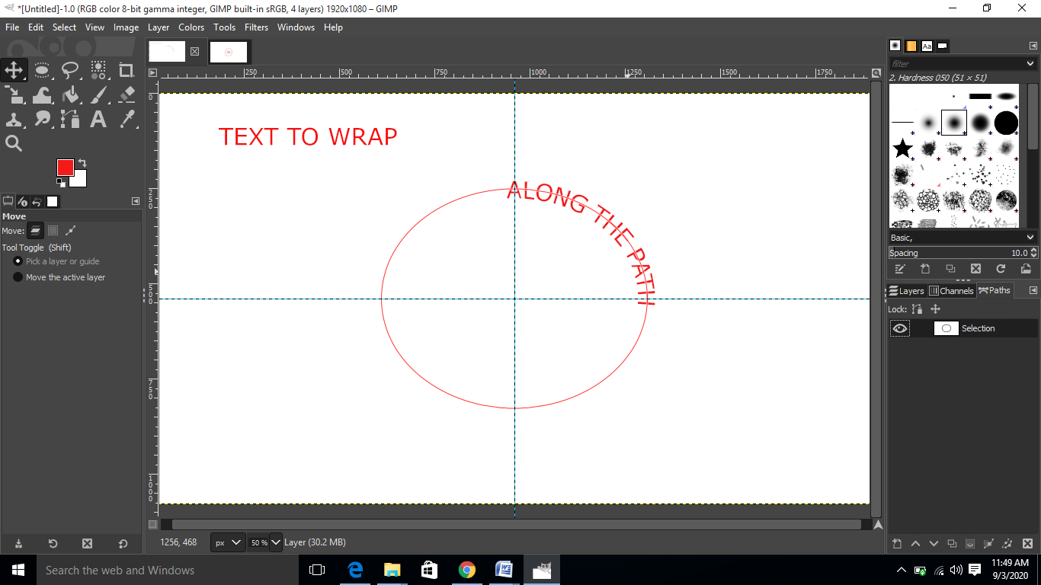

1. After that we are going to transform the text and repeat the same steps for the other text and the we will insert the image of Google logo inside the eclipse

